SMS System - Mobile Network

📲 SMS System in a Mobile Network — Overview
# Source: AI Source: Provided by: [Data Path: Persons Table -> ID Column: 1, Name_En Column: Motasem Essam] -> From: [ChatGPT] on [1/21/2026]
An SMS (Short Message Service) system in a mobile network is the architecture and process that allows mobile users to send and receive text messages. It involves several network elements, primarily centered around the SMSC (Short Message Service Center).

🧠 How SMS Works in a Mobile Network (GSM/3G/4G)
# Source: AI Source: Provided by: [Data Path: Persons Table -> ID Column: 1, Name_En Column: Motasem Essam] -> From: [ChatGPT] on [1/21/2026]
✅ Key Steps:
- User A sends an SMS from their phone.
- The message is routed via the Mobile Switching Center (MSC).
- It is handed over to the SMSC.
- If the recipient is available, SMSC forwards it immediately.
- If not, SMSC stores it and retries later.
- The message is delivered to User B via their MSC and Base Station.
- A delivery report may be sent back to User A.

📦 Core Components of the SMS System:
# Source: AI Source: Provided by: [Data Path: Persons Table -> ID Column: 1, Name_En Column: Motasem Essam] -> From: [ChatGPT] on [1/21/2026]
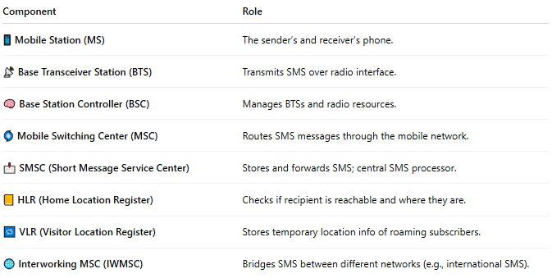

Component | Role
📱 Mobile Station (MS) | The sender’s and receiver’s phone.
📡 Base Transceiver Station (BTS) | Transmits SMS over radio interface.
🧠 Base Station Controller (BSC) | Manages BTSs and radio resources.
🌀 Mobile Switching Center (MSC) | Routes SMS messages through the mobile network.
📩 SMSC (Short Message Service Center) | Stores and forwards SMS; central SMS processor.
📒 HLR (Home Location Register) | Checks if recipient is reachable and where they are.
🔁 VLR (Visitor Location Register) | Stores temporary location info of roaming subscribers.
🌐 Interworking MSC (IWMSC) | Bridges SMS between different networks (e.g., international SMS).

🔁 Types of SMS by Communication Purpose:
# Source: AI Source: Provided by: [Data Path: Persons Table -> ID Column: 1, Name_En Column: Motasem Essam] -> From: [ChatGPT] on [1/21/2026]
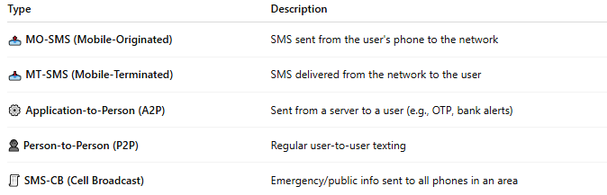

Type | Description
📤 MO-SMS (Mobile-Originated) | SMS sent from the user's phone to the network
📥 MT-SMS (Mobile-Terminated) | SMS delivered from the network to the user
⚙️ Application-to-Person (A2P) | Sent from a server to a user (e.g., OTP, bank alerts)
👤 Person-to-Person (P2P) | Regular user-to-user texting
🧾 SMS-CB (Cell Broadcast) | Emergency/public info sent to all phones in an area

🛠️ Protocols Used:
# Source: AI Source: Provided by: [Data Path: Persons Table -> ID Column: 1, Name_En Column: Motasem Essam] -> From: [ChatGPT] on [1/21/2026]
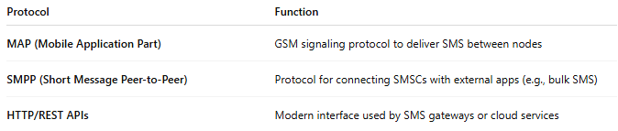

Protocol | Function
MAP (Mobile Application Part) | GSM signaling protocol to deliver SMS between nodes
SMPP (Short Message Peer-to-Peer) | Protocol for connecting SMSCs with external apps (e.g., bulk SMS)
HTTP/REST APIs | Modern interface used by SMS gateways or cloud services

📡 SMS System Architecture (Simplified Diagram):
# Source: AI Source: Provided by: [Data Path: Persons Table -> ID Column: 1, Name_En Column: Motasem Essam] -> From: [ChatGPT] on [1/21/2026]
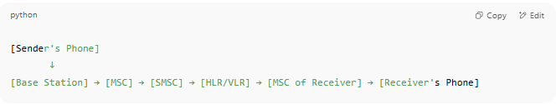

[Sender's Phone]
↓
[Base Station] → [MSC] → [SMSC] → [HLR/VLR] → [MSC of Receiver] → [Receiver's Phone]

📉 Limitations of SMS:
# Source: AI Source: Provided by: [Data Path: Persons Table -> ID Column: 1, Name_En Column: Motasem Essam] -> From: [ChatGPT] on [1/21/2026]
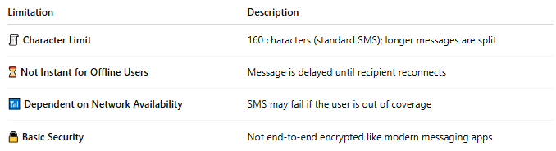

Limitation | Description
🧾 Character Limit | 160 characters (standard SMS); longer messages are split
⌛ Not Instant for Offline Users | Message is delayed until recipient reconnects
📶 Dependent on Network Availability | SMS may fail if the user is out of coverage
🔒 Basic Security | Not end-to-end encrypted like modern messaging apps

📖 Summary:
# Source: AI Source: Provided by: [Data Path: Persons Table -> ID Column: 1, Name_En Column: Motasem Essam] -> From: [ChatGPT] on [1/21/2026]
The SMS System in a mobile network is a structured chain of components:
- 🧠 SMSC acts as the central message manager
- 📡 RAN (radio) and MSC (switching) move SMS across the network
- 📒 HLR/VLR assist in locating recipients
- 🔄 Protocols like SMPP and MAP allow delivery and third-party integration
📩 It’s still widely used today for bank alerts, OTPs, emergency messaging, and global device communication.

